ADP GlobalView®

Master Data Requirements: Australia

RMIT Australia Pty Ltd

Commercial in Confidence

|  |  |
| --- | --- |
| **Author** | Kathy Fraser |
| **Document Reference** | GV00009336 |
| **Date** | 26/03/2020 |
| **Version** | 1.7 |

##### Copyright and Confidentiality

Copyright © 2015, 2016 ADP, LLC. ADP Proprietary and Confidential - All Rights Reserved. For Internal Use Only. These materials may not be reproduced in any format without the express written permission of ADP, LLC. This document must be kept strictly confidential at all times. It must not be disclosed to any person without the prior written consent of ADP, LLC.

ADP provides this publication "as is" without warranty of any kind, either express or implied, including, but not limited to, the implied warranties of merchantability or fitness for a particular purpose. ADP is not responsible for any technical inaccuracies or typographical errors which may be contained in this publication. Changes are periodically made to the information herein, and such changes will be incorporated in new editions of this publication. ADP may make improvements and/or changes in the product and/or the programs described in this publication at any time without notice.

The ADP® logo and ADP® letters are registered trademarks of ADP, LLC. GlobalView® is a registered trademark of ADP, LLC. iLearn@ADP® is a registered trademark of ADP, LLC. In the Business of Your Success(SM) is a service mark of ADP, LLC.

**Third-Party Trademarks**

Adobe® is a registered trademark and Acrobat(TM) is a trademark of Adobe Systems Incorporated.

Microsoft®, Windows®, Internet Explorer®, Word®, and Excel® are registered trademarks of Microsoft Corporation.

SAP® and SAP® R/3® are registered trademarks of SAP AG in Germany and in several other countries.

All other trademarks and service marks are the property of their respective owners.

##### Release Notice

This document applies to the ECC6 SAP R/3 version of the GlobalView® product solution. It is valid for ECC6-upgraded projects as well as new implementations done on the ECC6 template. It includes documentation of template enhancements from January 2011 and forward. Check the Document Attributes panel for reference to the ECC5 version.

##### Authorizations and Amendments History

| Version | Authored | Release Date | CRM Ticket | Approved |
| --- | --- | --- | --- | --- |
| 1.0 | Kathy Fraser | 27/09/2019 |  |  |
| 1.1 | Kathy Fraser | 09/10/2019 |  |  |
| 1.2 | Kathy Fraser | 21/10/2019 |  |  |
| 1.3 | Kathy Fraser | 07/11/2019 |  |  |
| 1.4 | Kathy Fraser | 28/11/2019 |  |  |
| 1.5 | Kathy Fraser | 15/01/2020 |  |  |
| 1.6 | Kathy Fraser | 04/01/2020 |  |  |
| 1.7 | Bre Dawson | 26/03/2020 |  |  |

##### Table of Contents

1. Master Data – Introduction 5

1.1 Initial Data Load (IDL) 5

1.2 ADP Spreadsheet Loader 5

1.3 Time Constraint Rules 6

1.4 Relationship between Infotypes and Records 6

1.5 Data Upload Sequence 7

2. RMIT AU Data Conversion 8

2.1 Initial Data Conversion 8

2.2 YTD Data 11

Long Service Leave Total Hours and Total Gross 12

2.3 Pre Go-Live Payments 14

2.4 Pre Go-Live Terminated Employees 14

2.5 Data Mapping 15

2.6 Time Data Requirements 15

3. Infotype Overview – General 24

Infotype 0000 – Actions 24

Infotype 0001 – Organisational Assignment 25

Infotype 0002 – Personal Data 26

Infotype 0006 – Addresses 27

Infotype 0007 – Planned Working Time 28

Infotype 0008 – Basic Pay 29

Infotype 0009 – Bank Details 30

Infotype 0011 – External Transfers 31

Infotype 0014 – Recurring Allowances and Deductions 32

Infotype 0015 – Additional Payments 33

Infotype 0016 – Contract Details 34

Infotype 0027 – Cost Distribution 35

Infotype 0041 – Date Specifications 36

Infotype 0045 – Loans 37

Infotype 0078 – Loan Payments 38

Infotype 0105 – Communications 39

Infotype 0709 – Global ID 40

Infotype 2001 – Absences 41

Infotype 2003 – Substitutions 42

Infotype 2006 – Absence Quotas 43

Infotype 2010 – Employee Remuneration Information 44

Infotype 2012 – Time Transfer Specifications 45

Infotype 2013 – Quota Corrections 46

4. Infotype Overview – Country Specific (AU) 47

Infotype 0188 – Tax Australia 47

Infotype 0220 – Superannuation Australia 48

Infotype 0227 – Tax File Number 49

Infotype 0817 – Withholding Tax Variation 50

5. Appendix 51

5.1 ADP Reference Documents 51

# Master Data – Introduction

GlobalView® categorises data types according to the following table –

| **Data Type** | **Data Set** | **Description** | **Meaning** |
| --- | --- | --- | --- |
| Infotype | P0000–P0999 | Payroll Infotypes | Infotypes required to process payroll  e.g. P0002 Personal Data, P0006 Addresses etc. |
| Infotype | P2000–P2020 | Basic Time Infotypes | Infotypes containing time events e.g. P2001 Absences, 2002 Attendances, 2003 Substitutions etc. |
| Other Master Data | BNKMD | Bank Keys | Bank-State-Branch numbers, bank names |
| Other Master Data | CCRMD | Cost Centres | Organisational Cost Centre codes |
| Other Master Data | WBSEL | WBS Element | WBS Element |
| Other Master Data | HROBJ | HR Objects | Position descriptions |
| New Hire | NHIRE | New Hire | Composite spreadsheet containing all the values required to create an Employee ID in the system |

### Initial Data Load (IDL)

Initial Data Load PECI Full Snapshot functionality focuses on data that can be extracted and transformed via PECI from the Workday system for clients implementing GlobalView payroll. It will create the HRMD Data Conversion files from Workday using the already tested PECI integration. Please note this must be used for both Parallel and Go-Live data conversion activities to ensure accuracy.

### ADP Spreadsheet Loader

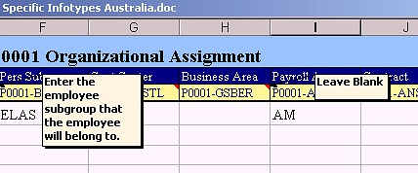ADP Spreadsheet Loader (SSL) is used to format data for loading into GlobalView®.

This document assumes familiarity with ADP Spreadsheet Loader (SSL) – refer to Appendix for detailed SSL End User Guides.

When completing the Upload Spreadsheets, check the notes in the column headings which will assist with entering the information correctly. Do not provide data where the note says leave blank. Red-lined cells indicate mandatory fields which must contain an entry.

SSL can be used for Master Data infotypes, Other Master Data, and transactional data.

Any of the Infotypes and Other Master Data types required may be selected for inclusion in an ADP SSL Workbook. Each data type is contained in a single worksheet as shown in the tabs at the bottom of the workbook –



### Time Constraint Rules

To maintain data integrity and prevent duplication of records every Infotype belongs to a Time Constraint class, which will determine whether a record must exist in the system at all times, whether multiple instances of the record can exist, and so on.

The following table provides a summary of Time Constraints –

| **Time Constraint** | **Rule** | **Includes** | **Examples** |
| --- | --- | --- | --- |
| 1 | Record must exist with no gaps, no overlaps | P0002 (Name) | Employee must always have a name record and can only have one name record |
| 2 | Record may include gaps but no overlaps | P2001 (Absence) | Employee does not have to be on leave but if on leave cannot be on more than one kind |
| 3 | Record may include gaps, and may overlap | P0009 (Bank Account) | Employee can have a number of secondary bank accounts and they may co-exist |

Refer to SSL End User Guides in the Appendix for detailed explanation.

### Relationship between Infotypes and Records

Infotypes are screens which gather data fields into logical groups. Records are created and maintained by the entry of data into Infotype screens. However records are different to infotypes.

A record is created when a start date is entered in an Infotype, either directly or via SSL.

This record has a beginning date of 02.02.2005 and continues indefinitely –



When a new record is created, say in the event of a name change, the End Date of the existing record is changed to the day before the new record’s Start Date. In other words the record is ‘delimited’ (if Time Constraint 1) –



Then the current record will start from the new date and continue indefinitely –



In overview, the records will look like this –

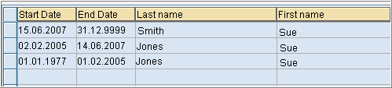

### Data Upload Sequence

During GlobalView® implementation, the sequence in which Infotypes and Other Master data types are uploaded is important. This is because certain values must be present in the system in order for records to be created.

**Upload Guidelines –**

* Cost Centre master data (CCRMD) must exist in the system prior to employee’s Organisational Assignment (P0001) being created if Cost Centre is to be assigned to an employee
* Bank Key master data (BNKMD) must be loaded before account information can be associated with an employee in Bank Detail (P0009)
* Creation of an Employee ID always requires a minimum of Infotypes 0000 (Actions), 0001 (Org. Assignment), 0002 (Personal Data), and 0041 (Date Specifications). The NHIRE worksheet is used to create new Employee IDs, as it contains all of these required entries
* Different countries have different Master Data requirements – while the general guidelines are the same, the particulars for each country may vary.

# RMIT AU Data Conversion

### Initial Data Conversion

For RMIT Australia Pty Ltd, it is expected that all initial data conversion will be performed by Initial Data Load (IDL) from WorkDay (WD). Additional master data and transactional data will be expected via SSL uploads (refer to Appendix for SSL templates). Any changes following Go-Live will then be managed by a combination of integration from WD HR system and SSL uploads.

The expected load sequence should be as per below –

| **Data Seq.** | **Object / Infotype** | **Description** | **Method** | **Note** |
| --- | --- | --- | --- | --- |
| 1 | BNKMD | Bank Master Data | SSL | Bank Keys |
| 1 | WBSEL | WBS Elements | SSL | WBS Elements |
| 1 | T5QSC | Superchoice Funds | Text | Download data from SE16 T5QSC |
| 2 | CCRMD | Cost Centre Master Data | IDL* | Cost Centres |
| 2 | HROBJ | Position Master Data | IDL* | Positions |
| 2 | NHIRE | NHIRE Employee Hire | IDL* | Employee Hire – includes P0000 Actions, P0001 Org Assignment, P0002 Personal Details, P0041 Date Specifications, P0709 Global ID (automatically loaded) |
| 2 | P0006 | Address | IDL* | Address |
| 2 | P0007 | Planned Working Time Infotype | IDL* | Work schedule details |
| 2 | P0008 | Basic Pay Infotype | IDL* | Salary details |
| 2 | P0105 | Communications Infotype | IDL* | Email, user ID |
| 2 | P0009 | Bank Details Infotype | IDL* | Bank details |
| 2 | P0027 | Cost Distribution Infotype | IDL* | Cost distribution overrides |
| 2 | P0227 | TFN Infotype | IDL* | TFN details |
| 2 | P0014 | Recurring Payments | IDL* | Recurring allowance details |
| *SSL template “NewHire” will be required for employees that are not being loaded through WD (for example employees who work in a second RMIT entity, workcover employees). In this case, please use WD ID followed by # to indicate that the employees are the same. If there is no WD ID, please assign a dummy ID outside the WD employee number range. | | | | |
| 3 | P2006 | Absence Quota | SSL Other Data | Absence quota shell |
| 3 | P2012 | Time Transfer Specifications | SSL Other Data | Time Override flags |
| 3 | P0027 | Cost Distribution | SSL Other Data | WBS field to store the WD position ID. The WBS must be created first, using SSL WBSEL |
| 3 | P0016 | Contract Elements | SSL Other Data | Contract details |
| 3 | P0188 | Tax Australia Infotype | SSL Other Data | Tax details |
| 3 | P0220 | Superannuation Infotype | SSL Other Data | Superannuation details |
| 3 | P0817 | Income Withholding Variation | SSL Other Data | Tax details |
| 3 | P0011 | External Transfers | SSL Other Data | Garnishee details |
| 3 | P0045 | Loans | SSL Other Data | Outstanding balance for MYKI and Overpayments |
| 3 | P0014 | Recurring Payments/Deductions | SSL Other Data | Recurring allowance/deduction details (not in WD). Please see the PY BP worksheet payment and deductions tabs. All WTs marked with “SSL” in the source column. |
| 3 | P0015 | Additional Payments/Deductions | SSL Other Data | Outstanding balance for purchase leave record |
| 4 | RPUTRBK0 | Update Control Record | - | Time retro accounting dates updated to reflect go-live date |
| 4 | RPTIME00 | Run Time Evaluation (1 day) | - | Create absence quota records to 31.12.9999 |
| 5 | P2013 | Quota Corrections | SSL Leave Balances | Leave balances (AL, LSL, PL, TIL, Purchased Lve, VE Teaching Leave) |
|  | RPTIME00 | Run Time Evaluation (1st Period) | - | Update quotas with leave balances |
| 7 | T558D&B | Payroll Account Transfer | SSL  PTD/ YTD | YTD payroll data for tax and average calculations |
| 8 | RPCALCQ0 | Run YTD Payroll | - | Create YTD payroll results |
| 8 | RPUTRBK0 | Update Control Record | - | Time & Payroll retro accounting dates updated to reflect go-live date |
| **GV Go-Live** | | | | |
| 9 | Payment Adjustment Data | Payment adjustment data for 1st week of timesheet data that cannot be sent via WD | SSL Transactional | Employee data loaded into IT0015 (Additional Payments), IT2010 (Employee Rem. Info |
| 9 | WD Transaction Data (PECI) |  | WD | Employee data loaded into IT0015 (Additional Payments) |
| 9 | WD G2 |  | WD | IT2002 (Attendances) IT2010 (Employee Rem. Info), IT2001 (Absences), IT2003 (Substitutions) |
| **Parallel 1 Transactional Data** | | | | |
| 10 | P0416 | Quota compensation | SSL Transactional | Only payouts, not termination payments |
| 10 | P2010 | Employee Remuneration Info | SSL Transactional |  |
| 10 | P2002 | Attendances | SSL Transactional |  |
| 10 | P2001 | Absence Data | SSL Transactional |  |
| 10 | P2003 | Substitution Data | SSL Transactional |  |
| **Parallel 2 & 3 Transactional Data** | | | | |
| 11 | NHIRE | NHIRE Employee Hire | SSL Transactional | If new hires require a new cost centre, WBS or Position to be created, please create via CCRMD, HROBJ, WBSEL within the SSL transactional template |
| 11 | P0000 | Terminations | SSL Transactional |  |
| 11 | P0001 | Organisational Changes | SSL Transactional | Only changes that will result in a change of pay. E.g. change from Perm to Casual |
| 11 | P0007 | Planned Working Time Infotype | SSL Transactional |  |
| 11 | P0008 | Basic Pay Infotype | SSL Transactional |  |
| 11 | P0011 | External Transfers | SSL Transactional |  |
| 11 | P0014 | Recurring Payments/Deductions | SSL Transactional |  |
| 11 | P0015 | Additional Payments | SSL Transactional |  |
| 11 | P0041 | Date Specification | SSL Transactional |  |
| 11 | P0045 | Loans | SSL Transactional | New Loans (Myki & Overpayments) only |
| 11 | P0416 | Quota compensation | SSL Transactional | Only payouts, not termination payments |
| 11 | P2010 | Employee Remuneration Info | SSL Transactional |  |
| 11 | P2002 | Attendances | SSL Transactional |  |
| 11 | P2001 | Absence Data | SSL Transactional |  |
| 11 | P2003 | Substitution Data | SSL Transactional |  |

** SSL required for all for master data changes in the pay period as these will not be provided via PECI for parallel runs

### YTD Data

For RMIT Australia Pty Ltd, the only historical payment data to be migrated will be data required to support payroll calculations. The below table outlines such data sets –

| **Data Set** | **Purpose** | **Method** | **Data Conversion Requirement** |
| --- | --- | --- | --- |
| KM Allowance | To ensure correct calculation of taxable and non-taxable KM claims post Go-Live | SSL  PTD/YTD | WT 93MK uploaded to T558B&D –  This should contain the total no of KMs claimed in the financial year up to the last pay period prior to go-live.  Can be loaded as 1 value into the pay period prior to go-live |
| Marginal Tax | To ensure correct calculation of marginally taxed payments | SSL  PTD/YTD | WTs /201 & 9J71 uploaded to T558B&D.  This should contain the average taxable earnings for each historical pay period in the prior pay periods in the financial year up to the last pay period prior to go-live. This should exclude pre-tax earnings.  Report from the RT results, per pay period |
| Service Fraction History | To enable calculation of paid parental leave | SSL  PTD/YTD | WT 9PLC uploaded to T558B&D.  RMIT University only, 3 years  Service Fraction % value for each pay period from 3 years before Go live (max 78 periods). The Unit field should be used to store the no of days in the fortnight (generally 14 except in mid-period hire) and the amount field is the units * service fraction. Example. Employee that is on 100% service fraction and active the whole period, will be loaded as 14 units, $1400. Example 2 : Employee that is on 60% service fraction and active the whole period, will be loaded as 14 units, $840. |
| Long Service Leave Total Hours and Total Gross | To enable calculation of LSL average calculation for casual employees | SSL  PTD/YTD | See below |
| **OPTIONAL**  Eligible Termination Payments - Other Taxable payments | To ensure correct calculations of Whole of Income Cap for any ETP payments made on termination in the financial year | SSL  PTD/YTD | WT I801 uploaded to T558B&D.  This should contain the other Taxable payments that have been paid in the financial year up to the last pay period prior to go-live that need to be included when calculating the WIC cap.  NOTE: this is only required when an ETP is being paid within the financial year, so can be loaded as needed during BAU. |
| Overpayments | To enable recovery of any existing overpayments post Go-Live | SSL Other Data | Following final payroll run, outstanding loan balance to be migrated to Infotype 0045 – Loan Payment using loan payment type 0300 Loan Balance Transfer , for loan type Z100 Overpayment |
| MYKI Balances | To enable recovery of any existing MYKI post Go-Live | SSL Other Data | Following final payroll run, outstanding loan balance to be migrated to Infotype 0045 – Loan Payment using loan payment type 0300 Loan Balance Transfer, for loan type Z101 MYKI |
| Purchased Leave Balances | To enable recovery of any existing Purchased Leave post Go-Live | SSL  Other Data | Following final payroll run, outstanding purchased leave balance to be migrated to Infotype 0015 – using WT 7715 Purch Leave Total, and fortnightly repayment amounts or percentage into IT0014 – WT 7716 Purch Leave Repay |

### Long Service Leave Total Hours and Total Gross

Permanent employees

Using **WT 9P03** we require the number of calendar days employee was active in period (for mid-period hires) in NUM field * weekly hours from WSR in AMT field

We will need this for every period going back 5 years from go-live (approx. 131 periods with leap years) and an entry which is an average from the time the employee was hire until the pay-by-pay breakdown.

For example: Employee hired on the 01.01.2010 and go live is 08.11.2020

Entry 1 should be the average hours and days worked from 01.01.2010 – 30.10.2015

The next 131 entries will be the pay by pay breakdown, from the 01.11.2015 (PP 10/2015) until go-live

Casual employees

Using **WT 9P07** we will need the cumulated causal earnings in AMT field and 2 in NUM filed (2 standard for 2 weeks)

We will need this for every period going back 5 years from go-live (approx. 131 periods with leap years) and an entry which is an average from the time the employee was hire until the pay-by-pay breakdown.

For example: Employee hired on the 01.01.2010 and go live is 08.11.2020

Entry 1 should be the average amount paid from 01.01.2010 – 30.10.2015

The next 131 entries will be the pay by pay breakdown, from the 01.11.2015 (PP 10/2015) until go-live

NOTE: we are expecting some employees will have YTDs for both 9P03 and 9P07 loaded, for employees that have worked multiple positions in the same entity

Completing the SSL

Start of Payroll Period, End of payroll Period, Payroll Year and Payroll Period all line up with your existing periods.

Payroll Area = QB

Please see attached for an example for each.



### Pre Go-Live Payments

Any payments required to be made to an employee for a period prior to GlobalView® Go-Live (eg. retro adjustment) will be required to be entered via Infotype 0015 gross, net or tax adjustment wage types in the first Go-Live pay period. This includes any overtime, leave, termination calculations, etc.

This will also include the TIME exception data for the **first** fortnightly payroll cycle. For example: ADP payroll go-live date Pay period 11 2020 (Period 08.11.2020 – 21.11.2020) this includes all casual timesheets **from 01.11.2020** – 14.11.2020. As go live is not until 08.11.2020, all timesheet entries from the 01.11.2020 – 07.11.2020 will require manual $ calculation and SSL entry into adjustment WTs into IT15.

Refer to the attached for available adjustment wage types.



### Pre Go-Live Terminated Employees

Any employees who may require post termination payments to be made (eg. bonus payments) should be migrated to GlobalView® as a pre go-live terminated employee.

These employees should be loaded with the date type ‘TD – Termination Date’ with the date of their termination date, this will ensure when the record is created the employment status will be loaded as Withdrawn.

The minimum data set required for these employees would be –

* IT0000 – Actions
* IT0001 – Organisational Details
* IT0002 – Personal Data
* IT0041 – Date Specifications (including additional ‘TD’ date type)
* IT0006 – Address
* IT0008 – Basic Pay
* IT0009 – Bank Details
* IT0105 – Communications
* IT0188 – Tax
* IT0220 – Superannuation
* IT0227 – TFN

Before payments can be made to the employee in GlobalView® they will need to have their control record updated with the end date of the pay period of the payment to ensure they are processed through payroll and payments made.

### Data Mapping

Legacy to GlobalView® data mapping tables should be created for all configuration values (eg. wage types, tax scales etc) in order to populate the SSL data load templates. The GlobalView® values can be sourced from a combination of Configuration Worksheet, Payroll Blueprint word document or the G2 specification. Links to all documents are contained in the Appendix.

The data mapping for the Parallel Payroll cycles should contain mapping for transactional data (eg. absences, employee movements, new hires, termination, additional payments, time based payments, etc) which will not be required at Go-Live.

### Time Data Requirements

The below details RMIT specific data migration requirements in relation to time infotypes. Some of these will only be required to be migrated as part of parallel run testing only and have been noted as such, the remaining infotypes are required for parallel run testing as well as for Go-Live.

Further details of the requirements have been details in the [Time Blueprint](https://portal221.globalview.adp.com/irj/servlet/prt/portal/prtroot/com.sap.km.cm.navigation/room_extensions/cm_stores/ADP_Project_Documents/workspaces/b086e86f-6880-3710-cb99-c151ffaa9238/B.%20Blueprint?StartUri=/room_extensions/cm_stores/ADP_Project_Documents/workspaces/b086e86f-6880-3710-cb99-c151ffaa9238), please refer to this as required.

**IT0041 – Date Specifications**

The below are the date types which should be included in the migration and who they are required for –

| **Data Type**  **DAR01 - DAR04** | **Date Type text** | **Date to be Loaded**  **DAT01 - DAT04** | **Purpose** |
| --- | --- | --- | --- |
| 01 | Country Hire Date | Hire Date | Employee’s most recent hire / re-hire date  To be loaded for All Fixed Term, Continuing and Casual employees |
| 02 | Company Hire Date | Hire Date | Employee’s original hire date (should only vary from 01 in cases of re-hire)  To be loaded for All Fixed Term, Continuing and Casual employees |
| QL | AU-LSL Annivers.Date | Anniversary Date -1 | Employee’s LSL service date  To be loaded for All Fixed Term, Continuing and Casual employees |
| QZ | Fixed Term End Date | Contract End Date | Fixed Term Employee’s contract end date  To be loaded for All Fixed Term employees only (ESG 3 + 4) |

**Please note this will be loaded via IDL for employees on WD, but will be required on the “newhire” SSL for employees that are not being loaded through WD (for example employees who work in a second RMIT entity)

**IT0416 – Quota Compensation (parallel only)**

Quota compensation data is only required to be loaded for parallel run to reflect any employee who has requested a leave cash out during the parallel run periods. For Go-Live these requests will be manually entered into GV (there is no integration from Workday for this). This relates to in-service cash outs and should not be entered for terminations. The below is required –

* **Date of Cash Out:** Date of cash out payment to be entered, start and end date should be the same (BEGDA + ENDDA)
* **Compensation Method (QCTYP):** Q001
* **Absence Quota Type (QTYPE):** Supported for 40 (Time Off in Lieu), 50 (Annual Leave) or 55 (Purchase Leave)
* **Number (NUMBR):** Enter number of hours to be cashed out

**IT2001 – Absences (parallel only)**

Absence data is only required to be loaded for parallel run as for Go-Live this data will be sent to GV via the Time Off G2 supplemental integration where the absence entry is for the current period.

For parallel run, the below is required –

* **Time Off absences:** To reflect the Workday integration method, Time Off absences should be loaded on a daily basis. For full day absences, only the absence type (AWART + SUBTY), current day start and end date are required to be loaded (BEGDA + ENDDA). The daily hours will automatically default. For part day absences, as well as absence type, current day start and end dates the total number of hours (STDAZ) should be loaded.
* **Leave of Absence (LOA) absences:** To reflect the Workday integration method, LOA absences should be loaded reflective of the actual start date and end date of the leave duration. For employees without a defined return from leave date as yet, the end date should be loaded as 31.12.9999. Only absence type (AWART + SUBTY), actual start and end dates should be loaded (BEGDA + ENDDA), no hours.

Refer to the [Time Blueprint](https://portal221.globalview.adp.com/irj/servlet/prt/portal/prtroot/com.sap.km.cm.navigation/room_extensions/cm_stores/ADP_Project_Documents/workspaces/b086e86f-6880-3710-cb99-c151ffaa9238/B.%20Blueprint?StartUri=/room_extensions/cm_stores/ADP_Project_Documents/workspaces/b086e86f-6880-3710-cb99-c151ffaa9238) for list of GV absence codes to be used in the load files (AWART), mapping of this is held in Workday.

**IT2002 – Attendances (parallel only)**

Attendance data is only required to be loaded for parallel run as for Go-Live this data will be sent to GV via the Time Tracking G2 supplemental integration where the timesheet entry is for the current period.

For parallel run, each attendance record should contain the below –

* **Date of Timesheet entry:** Start date and end date should reflect the same date (BEGDA + ENDDA)
* **Type of Timesheet entry:** Attendance type as per BP (AWART + SUBTY)
* **Timesheet Value:** Depending on the type of timesheet entry, this will either be Total Hours (STDAZ), or Start Time and End Time (BEGUZ + ENDUZ). Refer to the BP for input method for each attendance type
* **Rate** – For attendances related to secondary casual positions within the same entity, an hourly rate is required to be loaded with the attendance (BWGRL) along with currency (WAERS)
* **Cost Assignment** – Where project costing is required, WBS (Position ID + Project Task) and Cost Centre fields should be loaded (POSID + KOSTL). Where project costing is not required, only Cost Centre field should be loaded (KOSTL). In both scenarios, Controlling Area (KOKRS) and Company Code (BUKRS) should also be populated.

Refer to the [Time Blueprint](https://portal221.globalview.adp.com/irj/servlet/prt/portal/prtroot/com.sap.km.cm.navigation/room_extensions/cm_stores/ADP_Project_Documents/workspaces/b086e86f-6880-3710-cb99-c151ffaa9238/B.%20Blueprint?StartUri=/room_extensions/cm_stores/ADP_Project_Documents/workspaces/b086e86f-6880-3710-cb99-c151ffaa9238) for list of GV attendance types to be used in the load files (AWART), mapping of this is held in Workday.

**IT2003 – Substitutions (parallel only)**

Substitution data is only required to be loaded for parallel run as for Go-Live this data will be sent to GV via the Substitution G2 supplemental integration where the ad hoc schedule data is for the current period.

For parallel run, each substitution record should contain the below –

* **Date of Substitution:** Start date and end date should reflect the same date (BEGDA + ENDDA)
* **Substitution Type:** Substitution Type (VTART) and Subtype (SUBTY) defaulted to ‘01’
* **Substitution Hours:** Start time and end time of the shift (BEGUZ + ENDUZ) as well as start time and end time of any breaks (PBEG1 + PEND1). In the case of a substitution for an OFF day, the Daily Work Schedule (TPROG) should be populated with value of ‘OFF’ instead

**IT2010 – Employee Remuneration Info (parallel only)**

Allowance data is only required to be loaded for parallel run as for Go-Live this data will be sent to GV via the Time Tracking G2 supplemental integration where the timesheet allowance entry is for the current period.

For parallel run, each allowance record should contain the below –

* **Date of Timesheet entry:** Start date and end date should reflect the same date (BEGDA + ENDDA)
* **Type of Timesheet entry:** Wage type as per the BP (LGART + SUBTY)
* **Timesheet Value:** Both the number of the allowance entry (ANZHL) and currency (WAERS) should be populate

Refer to the [Time Blueprint](https://portal221.globalview.adp.com/irj/servlet/prt/portal/prtroot/com.sap.km.cm.navigation/room_extensions/cm_stores/ADP_Project_Documents/workspaces/b086e86f-6880-3710-cb99-c151ffaa9238/B.%20Blueprint?StartUri=/room_extensions/cm_stores/ADP_Project_Documents/workspaces/b086e86f-6880-3710-cb99-c151ffaa9238) for list of GV wage types to be used in the load files (LGART), mapping of this is held in Workday.

**IT2012 – Time Transfer Specifications**

The below Time Transfer specifications are required for any RMIT Training VE employees who were engaged as a Fixed Term or Continuing employee on 15 January 2017. This data will drive their eligibility to VE Teaching Leave entitlement. The below should be populated into Infotype 2012 –

* **Start Date (BEGDA):** Go-Live date (BEGDA)
* **End Date (ENDDA):** 31.12.9999 (ENDDA)
* **Time Transfer Type (ZTART):** ZTT1 (VE Teaching Lve Ent. Ovrd)
* **Hours (ANZHL):** 1

**IT2013 – Quota Compensation**

The below outlines how leave balance data should be migrated for each quota type.

**Time Off in Lieu –**

Leave balances should be loaded for all Fixed Term and Continuing employees as per below –

* **Start Date (BEGDA):** Go-Live Date
* **Absence Quota Type (KTART):** 40
* **Quota Number (ACCNU):** Only one record is required which contains employee’s total leave balance up to and including the day prior to Go-Live date (minus any absence data). Leave balance number should be in hours.
* **Operation Indicator (ACCOP):** +
* **Transfer Type (ACCTR):** Y

**Annual Leave –**

Leave balances should be loaded for all Fixed Term and Continuing employees, however there are variances based on the employee’s award.

All employees excluding RMIT Online –

* **Start Date (BEGDA):** Go-Live Date
* **Absence Quota Type (KTART):** 50
* **Quota Number (ACCNU):** Two records should be loaded – First record should contain the employee’s pro-rata leave accrual balance from 1st December of the year prior to Go-Live date up to and including the day prior to Go-Live date (minus any absence data). Second record should contain the employee’s leave entitlement balance (eg. employee’s leave balance as at 1st December of the year prior to Go-Live date minus any absence data). The separate records are required to ensure GV can correctly calculate the leave loading entitlement of the employee on the 1st December following Go-Live date. Any negative leave balances should be loaded as a negative value. Leave balance number should be in hours.
* **Operation Indicator (ACCOP):** Both accrual and entitlement records should be loaded as ‘+’
* **Transfer Type (ACCTR):** Accrual records should be loaded as ‘blank’; Entitlement records should be loaded as ‘Y’

RMIT Online employees –

* **Start Date (BEGDA):** Go-Live Date
* **Absence Quota Type (KTART):** 50
* **Quota Number (ACCNU):** Only one record is required which contains employee’s total leave balance (accrual and entitlement) up to and including the day prior to Go-Live date (minus any absence data). Leave balance number should be in hours.
* **Operation Indicator (ACCOP):** +
* **Transfer Type (ACCTR):** Y

**Purchase Leave –**

Leave balances should be loaded for all Fixed Term and Continuing employees as per below –

* **Start Date (BEGDA):** Go-Live Date
* **Absence Quota Type (KTART):** 55
* **Quota Number (ACCNU):** Only one record is required which contains employee’s total leave balance up to and including the day prior to Go-Live date (minus any absence data). Leave balance number should be in hours.
* **Operation Indicator (ACCOP):** +
* **Transfer Type (ACCTR):** Y

**Sick Leave –**

Leave balances should be loaded for all Fixed Term and Continuing employees as per below –

* **Start Date (BEGDA):** Go-Live Date
* **Absence Quota Type (KTART):** 60
* **Quota Number (ACCNU):** Only one record is required which contains employee’s total leave balance up to and including the day prior to Go-Live date (minus any absence data). Leave balance number should be in hours.
* **Operation Indicator (ACCOP):** +
* **Transfer Type (ACCTR):** Y

**Shadow Sick Leave –**

Leave balances should be loaded for all Fixed Term and Continuing employees as per below –

* **Start Date (BEGDA):** Go-Live Date
* **Absence Quota Type (KTART):** 62
* **Quota Number (ACCNU):** Only one record is required which contains a calculation of the employee’s sick leave accrual from their last anniversary prior to Go-Live up to and including the day prior to Go-Live date. This should not be reduced by any absence data. The calculation logic should be (Go-Live date – Anniversary date) x (Entitlement Days x Average Daily Hours / Days in Year). If there has been a change in FTE throughout the period this should be factored into the calculation. Leave balance number should be in hours.
* **Operation Indicator (ACCOP):** +
* **Transfer Type (ACCTR):** Blank

**Long Service Leave –**

Leave balances should be loaded for all Fixed Term, Continuing and Casual employees, however there are variances based on the employee’s eligible years of service.

Employee with less than 7yrs of service –

* **Start Date (BEGDA):** Go-Live Date
* **Absence Quota Type (KTART):** 70
* **Quota Number (ACCNU):** Only one record is required which contains the employee’s pro-rata leave accrual balance from their hire date up to and including the day prior to Go-Live date. This pro-rata balance should be based on an FTE equivalent daily accrual rate (eg. 9.1wks / 7yrs x 5d = 6.5d / 365 = 0.01781 days x number of calendar days). Leave balance number should be in days.
* **Operation Indicator (ACCOP):** +
* **Transfer Type (ACCTR):** Blank

Employee with 7yrs of service or greater –

* **Start Date (BEGDA):** Go-Live Date
* **Absence Quota Type (KTART):** 70
* **Quota Number (ACCNU):** Only one record is required which contains the employee’s leave entitlement from their hire date up to and including the day prior to Go-Live date (minus absence data). This will include the entitlement granted as at 7yrs of service as well as the subsequent entitlement granted daily thereafter. The entitlement balance should be based on an FTE equivalent daily accrual rate (eg. 9.1wks / 7yrs x 5d = 6.5d / 365 = 0.01781 days x number of calendar days pre 7yrs and 1.3wks / 1yrs x 5d = 6.5d / 365 = 0.01781 days x number of days after 7yrs). Leave balance number should be in days.
* **Operation Indicator (ACCOP):** +
* **Transfer Type (ACCTR):** Y

**Long Service Leave 78-93 –**

Leave balances should be loaded for all Fixed Term, Continuing and Casual employees.

* **Start Date (BEGDA):** Go-Live Date
* **Absence Quota Type (KTART):** 71
* **Quota Number (ACCNU):** Only one record is required which contains the employee’s entitlement balance accrued between 16 August 1978 (or hire date) and 17 August 1993. This entitlement should be based on an FTE equivalent daily accrual rate (eg. 9.1wks / 7yrs x 5d = 6.5d / 365 = 0.01781 days x number of calendar days). Leave balance number should be in days.
* **Operation Indicator (ACCOP):** +
* **Transfer Type (ACCTR):** Y

**Long Service Leave Pre 78 –**

Leave balances should be loaded for all Fixed Term, Continuing and Casual employees.

* **Start Date (BEGDA):** Go-Live Date
* **Absence Quota Type (KTART):** 72
* **Quota Number (ACCNU):** Only one record is required which contains the employee’s entitlement balance accrued between hire date and 15 August 1978. This entitlement should be based on an FTE equivalent daily accrual rate (eg. 9.1wks / 7yrs x 5d = 6.5d / 365 = 0.01781 days x number of calendar days). Leave balance number should be in days.
* **Operation Indicator (ACCOP):** +
* **Transfer Type (ACCTR):** Y

**VE Teaching Leave –**

Leave balances should be loaded for all Fixed Term and Continuing employees as per below –

* **Start Date (BEGDA):** Go-Live Date
* **Absence Quota Type (KTART):** 80
* **Quota Number (ACCNU):** Only one record is required which contains employee’s total leave balance up to and including the day prior to Go-Live date (minus any absence data). Leave balance number should be in days.
* **Operation Indicator (ACCOP):** +
* **Transfer Type (ACCTR):** Y

**IT2006 – Quotas**

Quota shell records are required for all absence quotas that an employee is entitled to, regardless of whether they hold a balance or not. The below is required to be loaded –

All records to have the Start Date (BEGDA) of Go-Live, End Date (ENDDA) of 31.12.9999, with the exception of VE Teaching Leave (Quota Type 80) which should be 31.12.xxxx with xxxx equal to the year of Go-Live.

This applies to the below quota types –

* 40 – Time Off in Lieu
* 50 – Annual Leave
* 55 – Purchase Leave
* 60 – Sick Leave
* 62 – Sick Leave Shadow
* 70 – Long Service Leave
* 80 – VE Teaching Leave

Additionally, the below additional Long Service Leave quotas should also have a quota shell created however are only required where the employee has an entitlement balance to be loaded into IT2013 –

* 71 – Long Service Leave 78-93
* 72 – Long Service Leave Pre 78

# Infotype Overview – General

## Infotype 0000 – Actions

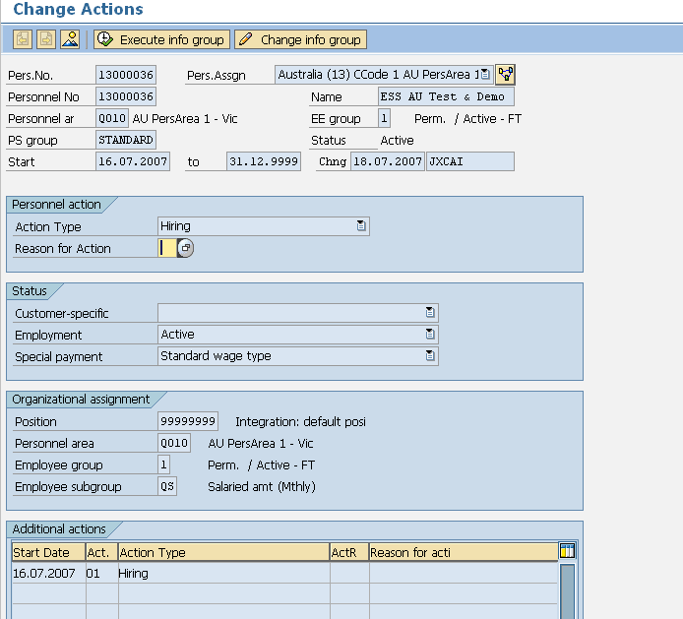

**Description:** All employees must hold an action infotype. It indicates if they are active or terminated and a new record is created when the action type (e.g. hire, transfer, termination) changes.

Key data –

* Employment Status
* Personnel Area
* Employee group
* Employee subgroup information

## Infotype 0001 – Organisational Assignment

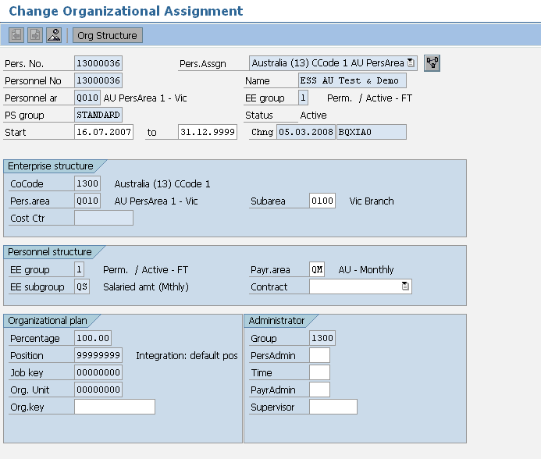

**Description:** This holds all organisational information such as company, location, department etc

Key data –

* Personnel Area – Company Code
* Personnel Sub Area – Location
* Employee Group – Type of worker (e.g. Perm, / Active - FT)
* Employee Subgroup – Employment Band
* Cost centre
* Payroll Area
* Position

## Infotype 0002 – Personal Data

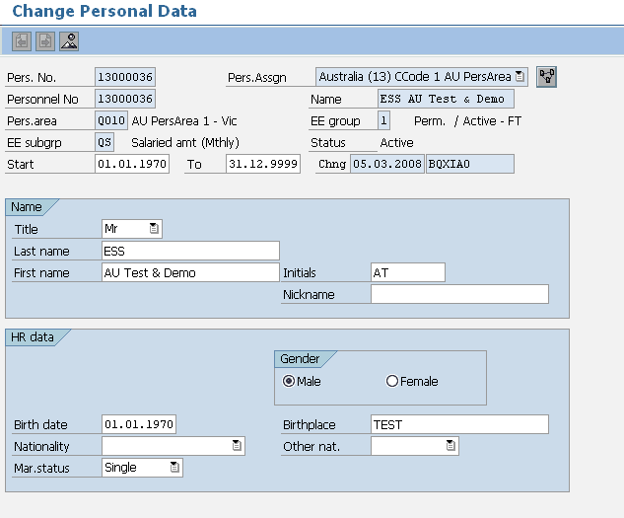

**Description:** This holds personal information relating to the employee.

Key data –

* Form of Address
* Last Name
* First Name
* Gender
* Birth Date

You also have the option of storing additional details if required.

Note that IT0001 and IT0002 can be reloaded separately if necessary. These are not required to be completed for the initial load.

## Infotype 0006 – Addresses

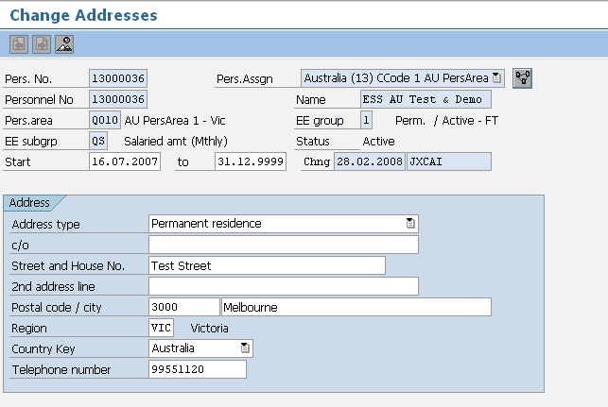

**Description:** Addresses Infotype 0006 data load sheet stores details of employee’s address. Employees may have more than one address type (i.e. Permanent Residence and Postal address). Creating an additional address record for that employee in the data load sheet allows for this.

Key data –

* Address Type (each employee must have Address Type 1 – other subtypes are optional)
* House Number / Street
* Postal Code – Four Digits
* City/District
* State
* Country

## Infotype 0007 – Planned Working Time

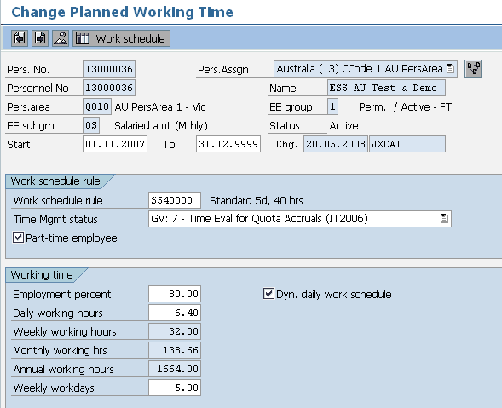

**Description:** Infotype 0007 holds employee work schedule information. The work schedule rule defines the hours worked. There will be a different rule for each country. There may be many more than one work schedule rule available in each country.

Key data –

* Work Schedule Rule
* Employee Time Management
* Part–Time Employee status

## Infotype 0008 – Basic Pay

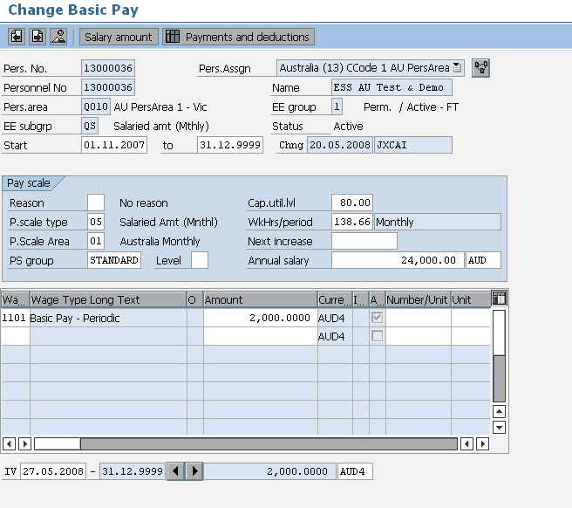

**Description:** This Infotype stores information about an employee’s salary and salary package. Additional Payments and Deductions are a separate Infotype.

Key data –

* The Employee’s Annual Salary
* The Employee’s Monthly Salary
* Additional Salary Package wage types if applicable
* Hourly rates if applicable
* Cap Util Level (employment percent)

## Infotype 0009 – Bank Details

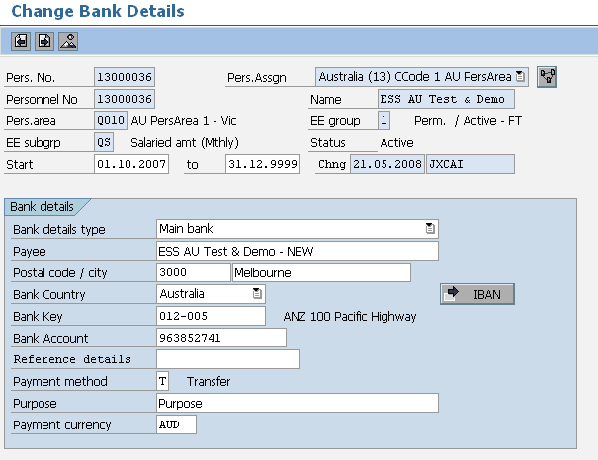

**Description:** This infotype holds details of the employee’s main bank account; an employee may have more than one bank details record. Additional banks hold the same details as the main bank but are entered through either an additional IT0009 record (in which case the money will come out of EVERY pay including off cycles) with a standard value or percentage or through an infotype 0011 record which works exactly like a deduction and will only come out of the main pay not an off cycle. Only employees with Payment method T will appear on the bank file.

Key data –

* Bank Type (0 = Main Bank) (1 = Other Bank)
* Payee
* Postal Code
* City
* Bank Country
* Bank Key
* Account Number
* Payment Method
* Standard Value or Percentage (if “other” bank type)

## Infotype 0011 – External Transfers

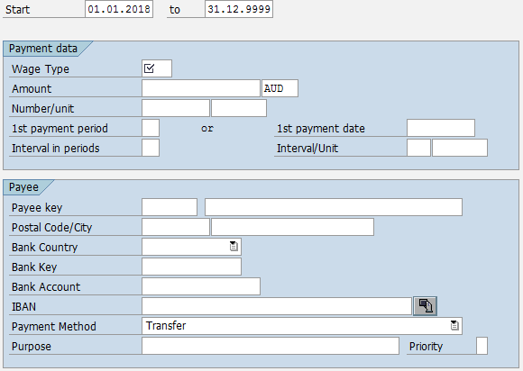

**Description:** External Transfers manages payments to third parties. The infotype defines the deduction to be made during payroll, and the destination to send it to. The design of this infotype is very similar to a combination of IT0014 Payments/Deductions and IT0009 Bank Details. This will be used to pay garnishments.

Key data –

* Wage Type
* Amount
* Payee Key
* Bank Country
* Bank Key
* Bank Account
* Payment Method

## Infotype 0014 – Recurring Allowances and Deductions

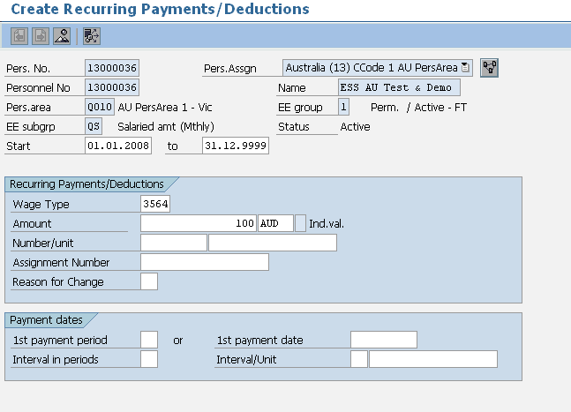

**Description:** Infotype 0014 stores the recurring allowances and deductions that are not included in the salary package; these wage types are permanent and paid monthly.

Key data –

* Wage Type
* Amount
* Number/Unit
* Currency
* Start and End Dates

## Infotype 0015 – Additional Payments

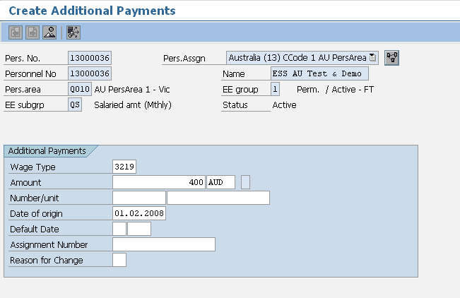

**Description:** Infotype 0015 is used for one off payments; these are known as ad–hoc payments.

Key data –

* Wage Type
* Amount
* Number/Unit
* Currency
* Date of Origin (Start and End Dates in the spreadsheet must be the same)

## Infotype 0016 – Contract Details

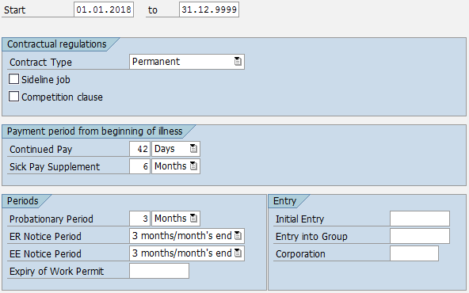

**Description:** Infotype 0016 stores the contract details as well as any applicable probation or notice periods.

This infotype is mandatory for RMIT for the Flexibility Index global strategic report.

Key data –

* Contract Type
* Employer Notice Period
* Employee Notice Period

## Infotype 0027 – Cost Distribution

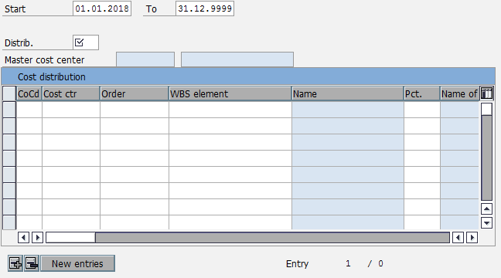

**Description:** This infotype is used to determine how costs for an employee are to be distributed to different account assignment objects. The employee is assigned in Infotype 0001 to a cost center and all her/his payroll cost will be sent to this cost center. This infotype allow assigning a part or all of the costs to another cost center, as an exception to the main cost center maintained in the infotype 0001.

Key data –

* Distribution
* Company Code
* Cost Centre
* Percentage

## Infotype 0041 – Date Specifications

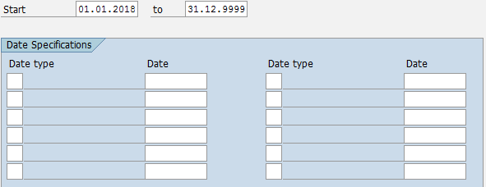

**Description:** Date Specifications holds key dates relating to the employee lifecycle. For example, date of entry to the organisation or date of eligibility to specific benefits.

Key data –

* Date Type
* Date

## Infotype 0045 – Loans

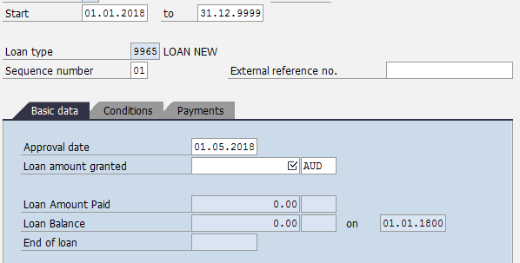

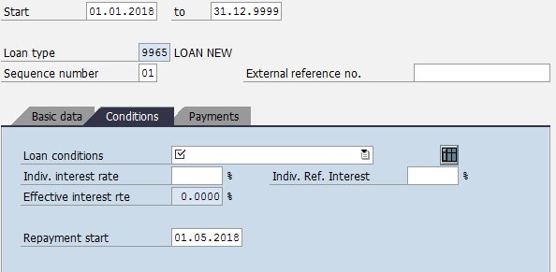

**Description:** Loans is used to hold details of loan arrangements made directly between the employee and the company. This infotype describes the loan conditions and repayment plans and is used by payroll to deduct or pay the entered amounts. The Infotype 0045 loan screen is made up of 3 tabs –

* Basic Data
* Conditions
* Payments (this tab is used to enter Infotype 0078 Loan Payment details)

Key data –

* Loan Type
* Approval Date
* Loan Amount Granted
* Loan Conditions
* Repayment Start Date

## Infotype 0078 – Loan Payments

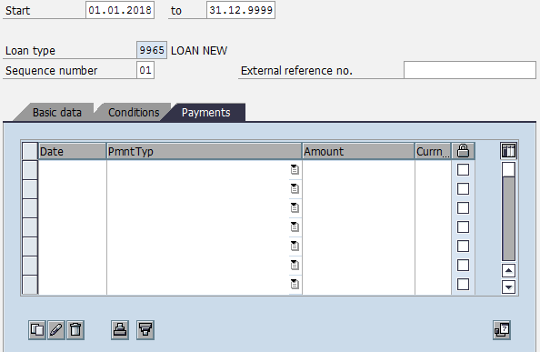

**Description:** Loan Payments should not be accessed directly, but instead is populated when data is entered in the Payments tab of IT0045.

Key data –

* Date
* Payment Type
* Amount
* Currency

## Infotype 0105 – Communications

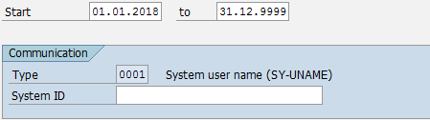

**Description:** This infotype is mandatory for ESS and MSS functionalities. It can be used to store multiple communication details for employees (eg. system user ID, email address, etc).

Key data –

* Communication Type
* ID

## Infotype 0709 – Global ID

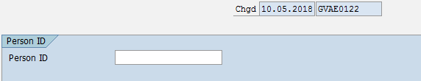

**Description:** Infotype 0709 will be used to store the Global ID of the employee. This is a unique identifier which identifies the employee in GV.

Key data –

* Person ID

## Infotype 2001 – Absences

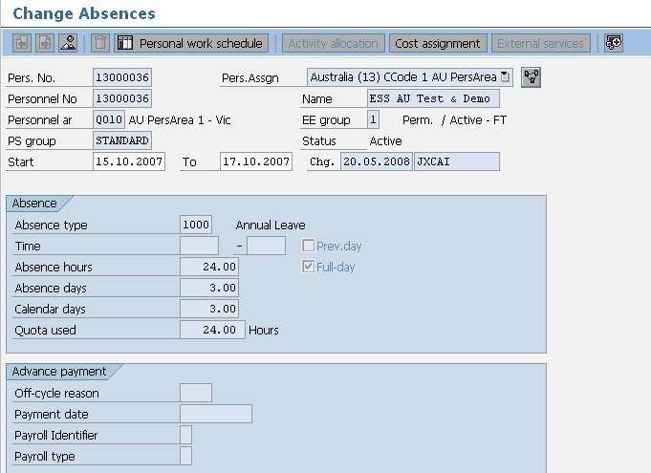

**Description:** This data load sheet loads employee leave entries. However in reality you will rarely need to load leave entries. It is either done by the payroll team or through ESS on an ad hoc basis.

Key data –

* Start and end Dates
* Wage Type
* Start and End Times/Absence Hours (only enter if less than one day’s leave is being applied for)

## Infotype 2003 – Substitutions

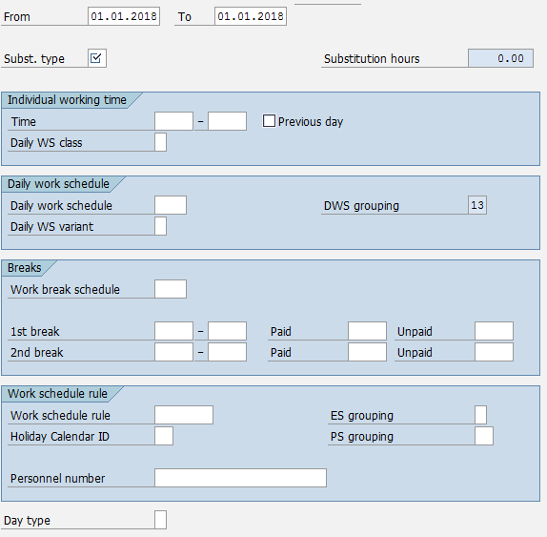

**Description:** Infotype 2003 is used to record deviations in an employee’s planned working time on the Planned Working Times Infotype (0007). Substituting planned working time based on daily work schedule, work schedule rule and/or periods of time in a day is permitted.

Key data –

* Substitution Type
* Time – Start and End Times
* Day Type

## Infotype 2006 – Absence Quotas

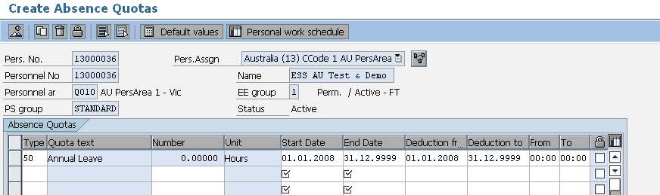

**Description:** In SAP leave is recorded as an absence. Some absences are linked to leave quotas that hold the entitlement and pro–rata values. These leave types are annual leave, sick leave and long service leave etc. When employees are hired a record is created for annual leave, sick leave and long service leave but no quotas are loaded at this point, they are left blank.

Key data –

* Start and End/To Dates
* Leave Type (e.g. Annual = 50, Sick/Personal Leave = 60, Long Service Leave = 70)

## Infotype 2010 – Employee Remuneration Information

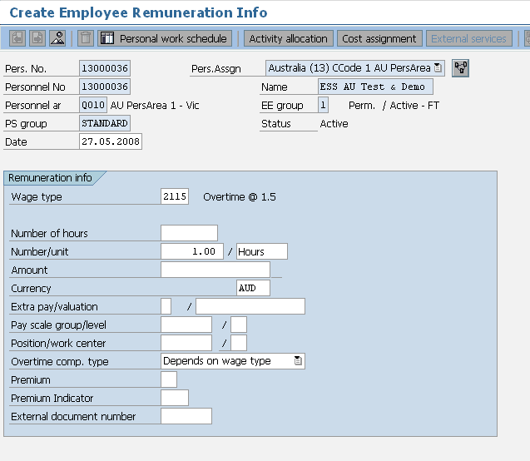

**Description:** This is used to input time sheet entries such as overtime and meal allowances. However this is sometimes done via ESS or manually by the payroll team.

Key data –

* Start and End Dates
* Wage Type
* Amount/Hours
* Note that in the spreadsheet there is a field for Cost centre so that a payment can be assigned to a different cost centre. To do this manually you would click on the cost assignment button.

## Infotype 2012 – Time Transfer Specifications

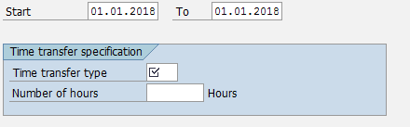

**Description:** Infotype 2012 is used to store time information which is read and used in time evaluation for various purposes.

Key data –

* Time Transfer Type
* Number

## Infotype 2013 – Quota Corrections

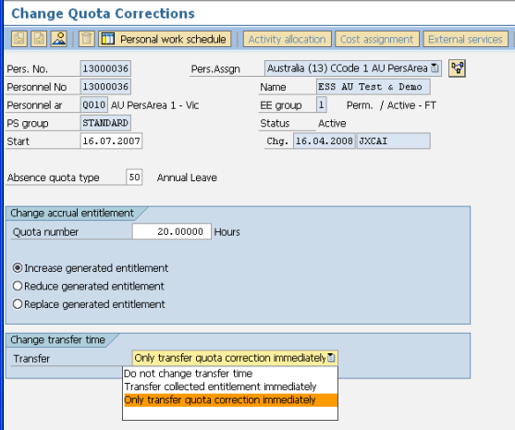

**Description:** Infotype 2013 allows you to increase, reduce or replace leave balances for the appropriate leave type. Therefore when you have loaded an IT2006 for each employee for each leave type that they are entitled to you can use this infotype to load the existing balances into IT2006.

Key data –

* From and To Dates must be the same
* Quota Type
* Quota Number
* Increasing, Reducing, or Replacing Leave Balance
* Transfer Time

# Infotype Overview – Country Specific (AU)

## Infotype 0188 – Tax Australia

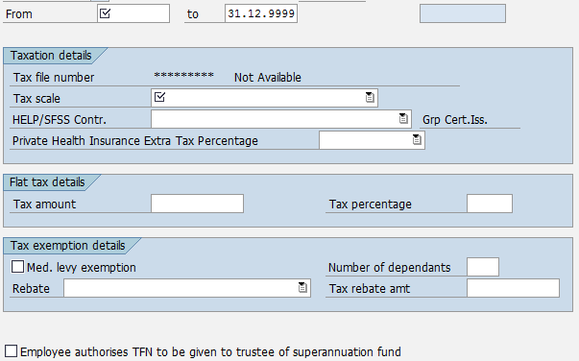

**Description:** Infotype 0188 stores Australia Tax Information including Tax Scale information.

Key data –

* Tax Scale
* HECS/SFSS Contribution Category
* Details of any Flat Tax Amounts
* Tax exemption details and rebates
* Medicare Exempt
* Dependant Information
* TFN to Super Fund flag

## Infotype 0220 – Superannuation Australia

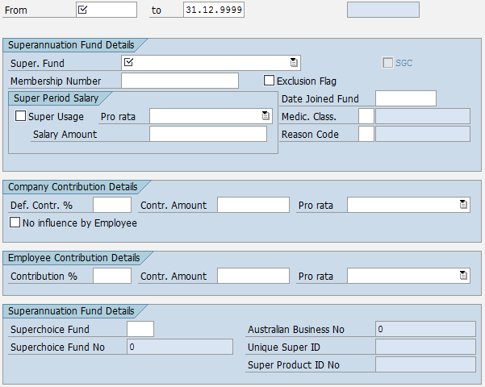

**Description:** Superannuation Australia details are loaded through Infotype 0220.

Key data –

* Superannuation Fund Type
* Super Fund Member Number
* Date Joined
* Salary details if the salary used for super calculation is different to the basic salary
* Details of medical classification (if the employee has had to undergo an examination to join the fund) along with the reason code.
* Contribution details are displayed here but maintained within the system
* Superchoice Fund code
* Australian Business No
* Super Fund No
* Super Product ID No

## Infotype 0227 – Tax File Number

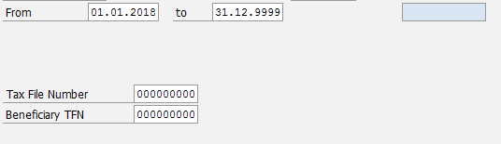

**Description:** Infotype 0227 enables employee’s Tax File Numbers to be loaded.

Key data –

* Start and End Dates (End Date should be 31.12.9999)
* Tax File Number (Should be 9 digit number)

## Infotype 0817 – Withholding Tax Variation

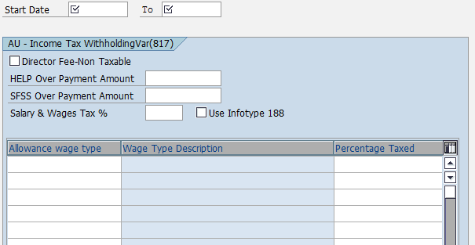

**Description:** The Tax Australia record (IT0188) is the master record for determining an employee’s tax deduction. The details stored in this record are the standard tax scales and rebate keys that are applicable for all employees Australia wide.

There are circumstances however, where an individual has received a ruling from the tax office for their personal circumstances, or where an organisation has received a ruling about a specific payment that can have a different tax treatment. In this case an additional tax record, Income Tax Withholding Variation (IT0817) may be needed.

The tax ruling may only apply to a specific payment the employee receives and not the taxable gross. The details stored in IT0188 apply to the taxable gross. The details in IT0817 can apply to a specific payment only. An example is where an employee has received a variation on their salary and wages, bonuses however are to be taxed as per the standard tax scale. In this case an ITWV record is required to enter details for the salary and wages tax percentage. The tax on bonuses is determined by the tax scale in IT0188. The payroll will use the details stored in both records (IT0188 & IT0817) to deduct the correct amount from the taxable gross components in the payroll.

This record would exist only where an employee has received a tax ruling from the ATO. Without official documentation from the ATO a record should not be created.

Key data –

* Director Fee Non Taxable
* HELP Overpayment Amount
* SFSS Overpayment Amount
* Salary and Wages Tax Percentage
* Use Infotype 0188 flag
* Wage Type
* Percentage Taxed

# Appendix

### ADP Reference Documents

| **ADP GV Document ID** | **Description** | **Document** |
| --- | --- | --- |
| GV00002671 | G2 SSL Data Entry |  |
| GV00009265 | Data Load with the ADP SSL Interface |  |
| [A-PMS0008](https://portal221.globalview.adp.com/irj/servlet/prt/portal/prtroot/com.sap.km.cm.navigation/room_extensions/cm_stores/ADP_Project_Documents/workspaces/e022f269-0f29-3610-d894-aa1cc65e30ca/C.%20Interfaces/Functional%20Specs?StartUri=/room_extensions/cm_stores/ADP_Project_Documents/workspaces/e022f269-0f29-3610-d894-aa1cc65e30ca) | RMIT AU G2 Specification | [Project cRoom](https://portal221.globalview.adp.com/irj/portal?NavigationTarget=CollaborationConnector://portal_content/com.sap.ip.collaboration/Rooms/0097866c-6880-3710-8ea2-f285dc4b04cd/workset) |
| GV00006546 | RMIT AU Blueprint Configuration Worksheet | [Project cRoom](https://portal221.globalview.adp.com/irj/portal?NavigationTarget=CollaborationConnector://portal_content/com.sap.ip.collaboration/Rooms/0097866c-6880-3710-8ea2-f285dc4b04cd/workset) |
| GV00006552 | RMIT AU ADP GV - Payroll Business Blueprint | [Project cRoom](https://portal221.globalview.adp.com/irj/portal?NavigationTarget=CollaborationConnector://portal_content/com.sap.ip.collaboration/Rooms/0097866c-6880-3710-8ea2-f285dc4b04cd/workset) |
|  | RMIT AU ADP GV - Time Business Blueprint | [Project cRoom](https://portal221.globalview.adp.com/irj/portal?NavigationTarget=CollaborationConnector://portal_content/com.sap.ip.collaboration/Rooms/0097866c-6880-3710-8ea2-f285dc4b04cd/workset) |
| [GV00003434](https://portal221.globalview.adp.com/irj/servlet/prt/portal/prtroot/com.sap.km.cm.navigation/room_extensions/cm_stores/ADP_Global_Project_Documents/workspaces/20c39902-a9a6-3510-10b1-a2ce70767711/2-Global%20Design%20(GTD%2cxSS%2cGTD)/GTD/GTD%20Final%20versions?StartUri=/room_extensions/cm_stores/ADP_Global_Project_Documents/workspaces/20c39902-a9a6-3510-10b1-a2ce70767711) | RMIT Global Template Document | [Project cRoom](https://portal221.globalview.adp.com/irj/portal?NavigationTarget=CollaborationConnector://portal_content/com.sap.ip.collaboration/Rooms/0097866c-6880-3710-8ea2-f285dc4b04cd/workset) |
| - | SSL Template | [Project cRoom](https://portal221.globalview.adp.com/irj/portal?NavigationTarget=CollaborationConnector://portal_content/com.sap.ip.collaboration/Rooms/0097866c-6880-3710-8ea2-f285dc4b04cd/workset) |
| - | Template – YTD Data Example | [Project cRoom](https://portal221.globalview.adp.com/irj/portal?NavigationTarget=CollaborationConnector://portal_content/com.sap.ip.collaboration/Rooms/0097866c-6880-3710-8ea2-f285dc4b04cd/workset) |